**RECEIVING SMS using TATTOO – VB.NET**

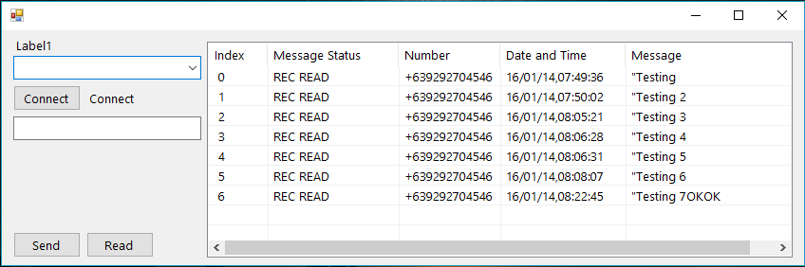

**Syntax:**

Imports System.Management

Imports System.IO

Imports System.Threading

Imports System.Text.RegularExpressions

Public Class Form1

Dim rcvdata As String = ""

Dim WithEvents SerialPort As New IO.Ports.SerialPort

Private Sub Form1_Load(sender As Object, e As EventArgs) Handles MyBase.Load

Dim ports() As String

ports = Split(ModemsConnected(), "***")

For i As Integer = 0 To ports.Length - 2

ComboBox1.Items.Add(ports(i))

Next

connection()

exJm()

End Sub

Private Sub serialport1_datareceived(ByVal sender As Object, ByVal e As System.IO.Ports.SerialDataReceivedEventArgs) Handles SerialPort1.DataReceived

'Pause while all data is read

System.Threading.Thread.Sleep(1000)

Dim datain As String = ""

Dim numbytes As Integer = SerialPort1.BytesToRead

For i As Integer = 1 To numbytes

datain &= Chr(SerialPort1.ReadChar)

Next

test(datain)

End Sub

Private Sub test(ByVal indata As String)

rcvdata &= indata

End Sub

Public Function ModemsConnected() As String

Dim modems As String = ""

Try

Dim searcher As New ManagementObjectSearcher(

"root\CIMV2",

"SELECT * FROM Win32_POTSModem")

For Each queryObj As ManagementObject In searcher.Get()

If queryObj("Status") = "OK" Then

modems = modems & (queryObj("AttachedTo") & " - " & queryObj("Description") & "***")

End If

Next

Catch err As ManagementException

MessageBox.Show("An error occurred while querying for WMI data: " & err.Message)

Return ""

End Try

Return modems

End Function

Private Sub ComboBox1_SelectedIndexChanged(sender As Object, e As EventArgs) Handles ComboBox1.SelectedIndexChanged

Label1.Text = Trim(Mid(ComboBox1.Text, 1, 5))

End Sub

Private Sub exJm()

Try

With SerialPort1

rcvdata = ""

.Write("AT" & vbCrLf)

Threading.Thread.Sleep(1000)

.Write("AT+CMGF=1" & vbCrLf)

Threading.Thread.Sleep(1000)

.Write("AT+CPMS=""SM""" & vbCrLf)

Threading.Thread.Sleep(1000)

.Write("AT+CMGL=""ALL""" & vbCrLf)

Threading.Thread.Sleep(1000)

.Write("AT+CMGL=""REC UNREAD""" & vbCrLf)

Threading.Thread.Sleep(1000)

'MsgBox(rcvdata.ToString)

readmsg()

End With

Catch ex As Exception

MsgBox(ex.Message)

End Try

End Sub

Private Sub Button3_Click(sender As Object, e As EventArgs) Handles Button3.Click

Try

With SerialPort1

rcvdata = ""

.Write("AT" & vbCrLf)

Threading.Thread.Sleep(100)

.Write("AT+CMGF=1" & vbCrLf)

Threading.Thread.Sleep(100)

.Write("AT+CPMS=""SM""" & vbCrLf)

Threading.Thread.Sleep(100)

.Write("AT+CMGL=""REC UNREAD""" & vbCrLf)

Threading.Thread.Sleep(100)

.Write("AT+CMGL=""ALL""" & vbCrLf)

Threading.Thread.Sleep(100)

'MsgBox(rcvdata.ToString)

readmsg()

End With

Catch ex As Exception

MsgBox(ex.Message)

End Try

End Sub

Private Sub readmsg()

Try

Dim lineoftext As String

Dim i As Integer

Dim arytextfile() As String

lineoftext = rcvdata.ToString

arytextfile = Split(lineoftext, "+CMGL",, CompareMethod.Text)

For i = 1 To UBound(arytextfile)

Dim input As String = arytextfile(i)

Dim result() As String

Dim pattern As String = "(:)|(,"")|("","")"

result = Regex.Split(input, pattern)

Dim lvi As New ListViewItem

Dim concat() As String

With ListView1.Items.Add("null")

'for index

.SubItems.AddRange(New String() {result(2)})

'for status

.SubItems.AddRange(New String() {result(4)})

'for number

Dim my_string, position As String

my_string = result(6)

position = my_string.Length - 2

my_string = my_string.Remove(position, 2)

.SubItems.Add(my_string)

'for date and time

concat = New String() {result(8) & result(9) & result(10) & result(11) & result(12).Substring(0, 2)}

.SubItems.AddRange(concat)

'for message

Dim lineoftexts As String

Dim arytextfiles() As String

lineoftexts = arytextfile(i)

arytextfiles = Split(lineoftexts, "+32", , CompareMethod.Text)

.SubItems.Add(arytextfiles(1))

End With

Next

Catch ex As Exception

MsgBox(ex.Message)

End Try

End Sub

Sub connection()

Try

With SerialPort1

.PortName = "COM7"

.BaudRate = 9600

.Parity = IO.Ports.Parity.None

.DataBits = 8

.StopBits = Ports.StopBits.One

.Handshake = Ports.Handshake.None

.RtsEnable = True

.DtrEnable = True

.Open()

End With

If SerialPort1.IsOpen Then

Label2.Text = "Connect"

Else

Label2.Text = "Disconnect"

End If

Catch ex As Exception

MsgBox(ex.Message)

End Try

End Sub

Private Sub Button1_Click(sender As Object, e As EventArgs) Handles Button1.Click

Try

With SerialPort1

.PortName = "COM7"

.BaudRate = 9600

.Parity = IO.Ports.Parity.None

.DataBits = 8

.StopBits = Ports.StopBits.One

.Handshake = Ports.Handshake.None

.RtsEnable = True

.DtrEnable = True

.Open()

End With

If SerialPort1.IsOpen Then

Label2.Text = "Connect"

Else

Label2.Text = "Disconnect"

End If

Catch ex As Exception

MsgBox(ex.Message)

End Try

End Sub

End Class